Version <1.0>

Revision History

|  |  |  |  |
| --- | --- | --- | --- |
| **Date** | **Version** | **Description** | **Author** |
| <dd/mmm/yy> | <1.0> | <details> | Nguyen Kiem Hoa |
|  |  |  |  |
|  |  |  |  |
|  |  |  |  |

Table of Contents

1. Change Password 4

1.1 Brief Description 4

1.2 Actor 4

2. Flow of Events 4

2.1 Basic Flow 4

3. Special Requirements 4

4. Preconditions 4

5. Postconditions 4

6. Extension Points 4

# Change Password

## Brief Description

This use case defines the steps of changing password when user want. User can easily change their password with some simple steps.

## Actor

User

# Flow of Events

## Basic Flow

User need click on ‘Change password’ button at Profile interface and a change password form appear. Then, user need fill all necessary information and click change password. After that, if new password is valid, user’s pass will be change, else an message invalid password will appear.

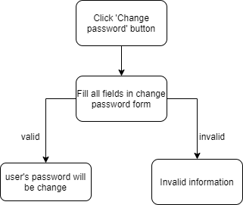

# Special Requirements

Click ‘change password’ from Profile interface.

# Preconditions

Fill correct information in fields.

# Postconditions

If valid information, password will be change

Else warning ‘Invalid information’.

# Extension Points

No extension point.